About Us
We license beautiful designs by talented artists to wholesalers and manufacturers who create aesthetic products for the marketplace. We do not sell any products.
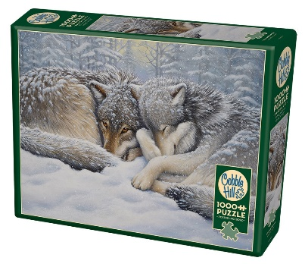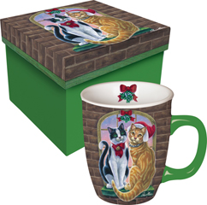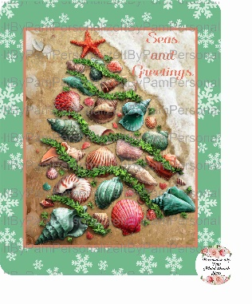
Our Story
Creative Connection, Inc. represents highly skilled artists and licenses their images to manufacturers who use designs on their products. Our company was founded by mother-daughter duo, Parker Fulton and Laurie High, in the early 1990’s. Parker’s vast experience as a successful illustrator herself has provided an invaluable bridge between artists and clients. Laurie’s business background and education has provided the essential operations knowledge needed for marketing and accounting. Recently, Jennifer Lewis (Parker’s daughter and Laurie’s sister) joined Creative Connection in a Marketing capacity. She is also responsible for our Social Media accounts.
Our Designs
We offer the finest in art and design and have thousands of quality images available for licensing in a broad spectrum of categories. Our artists are available for commissioning as well.
Creative Connection, Inc. is a popular source for Wildlife, Holiday, Judaica, Pet, Horse, Floral, Inspirational designs and more. Our designs appear on many products including giftware, garden flags, needlepoint, throws, puzzles, metal signs and stationery to name a few.

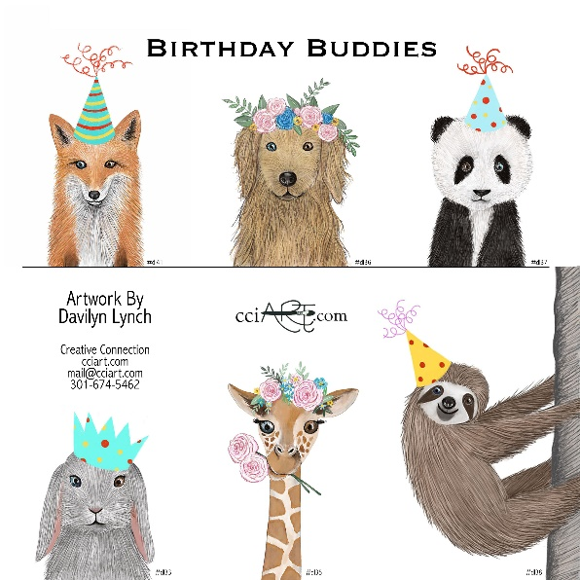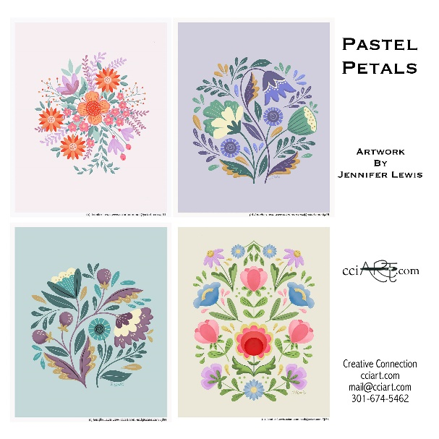
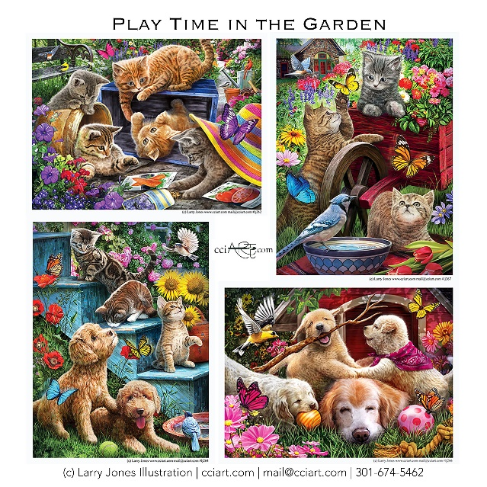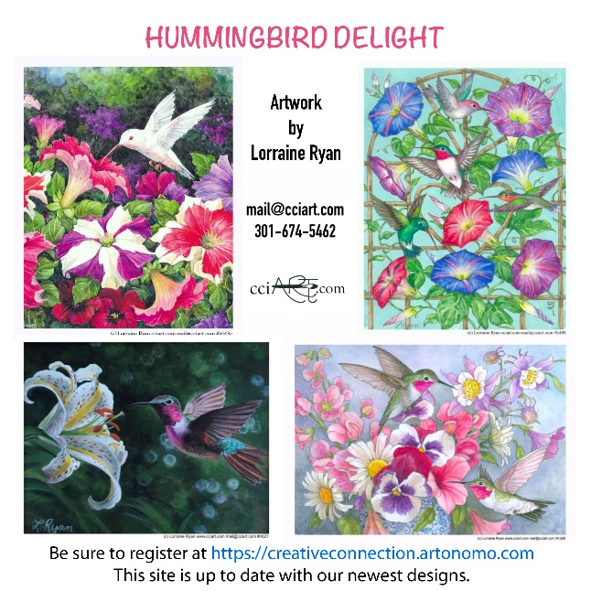
NEWS
Puzzles/Coloring Apps: This is a relatively new category for us and one that seems to be growing rapidly. Currently, five of our artists are licensed in these markets. These relaxing hobbies are more fun with our designs!
Metal Signs: Crafters like this product for sprucing up the middles of their handmade wreaths. A handful of our artists are licensed with these manufacturers so far, and we hope to have interest in additional artwork soon.
Jigsaw and Wooden Puzzles: This still proves to be a huge market for our artists, despite some manufacturing hiccups and overstock issues that some of these companies are experiencing. Once they recover from these issues, we expect even more licenses.
Creative Connection, Inc. - 301-674-5462 - mail@cciart.com

